BIT 4107 – Mobile Application Development
ENHANCED PROFESSIONAL STUDENT LOGBOOK

Student Name: JOY MUSENYA
Admission Number: BIT/2024/74499
School/Faculty: BACHELOR OF SCIENCE IN INFORMATION AND TECHNOLOGY
Programme:
Academic Year: 2025/2026
Semester: TWO
Lecturer: MR.NYORO
Phone Number: 0715562770

Week 1: Introduction to Mobile Application Development

TASK 1: DEVELOPMENT TOOLS ASSEMENT
I had the following tools in my device so the was no need for me to install them again …
I identified them by running these commands in the cmd.

- Java Development kit
Version: java -version
Status: installed and working
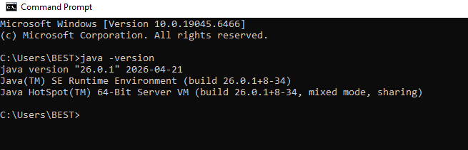

- Node .js
Version: node –version
Status: installed
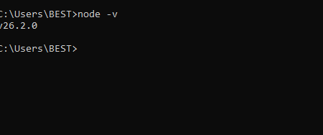

- Git
Version: git – version
Status: installed
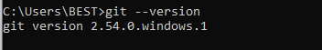

fl
- Vs code
Version: code - -version
Status: installed
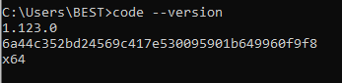

5.flutter sdk
Version: flutter –version
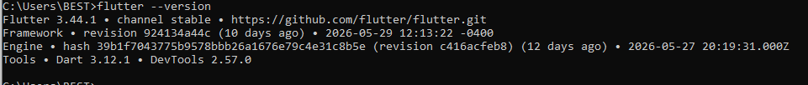
- Flutter doctor to check whether my flutter setup is complete
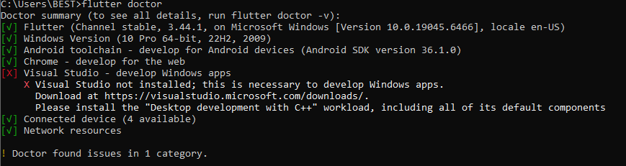

6.Had to install Android studio
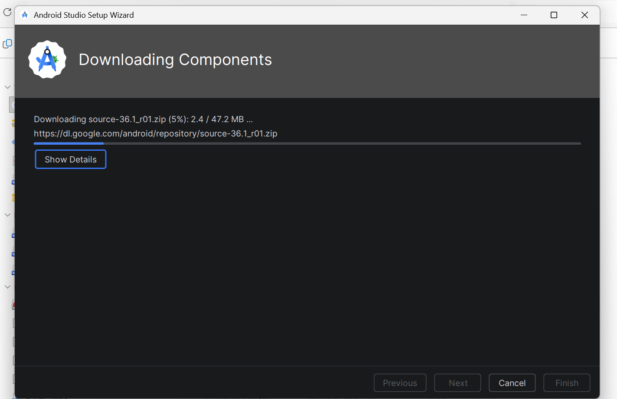

NB : I used my phone for testing because the Android emulator had technical issues on my computer, and a physical device provided a reliable alternative .Which is shown below:

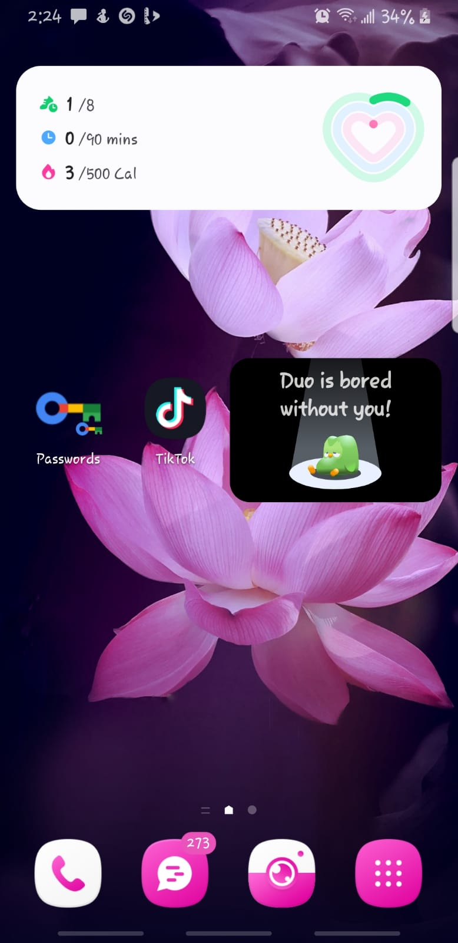

Task 2. First app creation
App title: my first app
Background color :white
Font-size:16
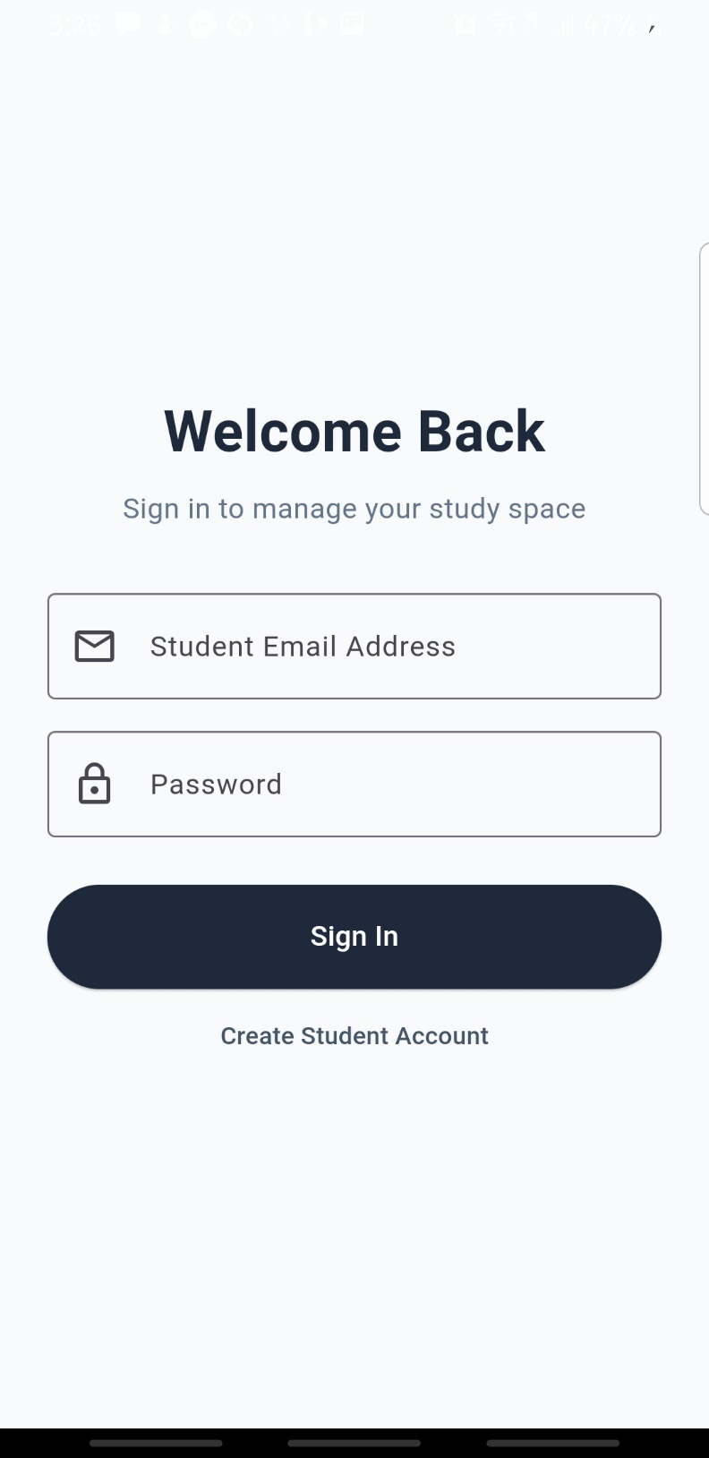
TASK 3 : CHALLENGES AND SOLUTIONS
Challenge One :
Problem: My emulator started malfunctioning and lagging on my PC.
Trial: I freed some space on my PC to improve the PC performance and looked for an alternative
Solution: I connected my phone to my PC and used it as my emulator
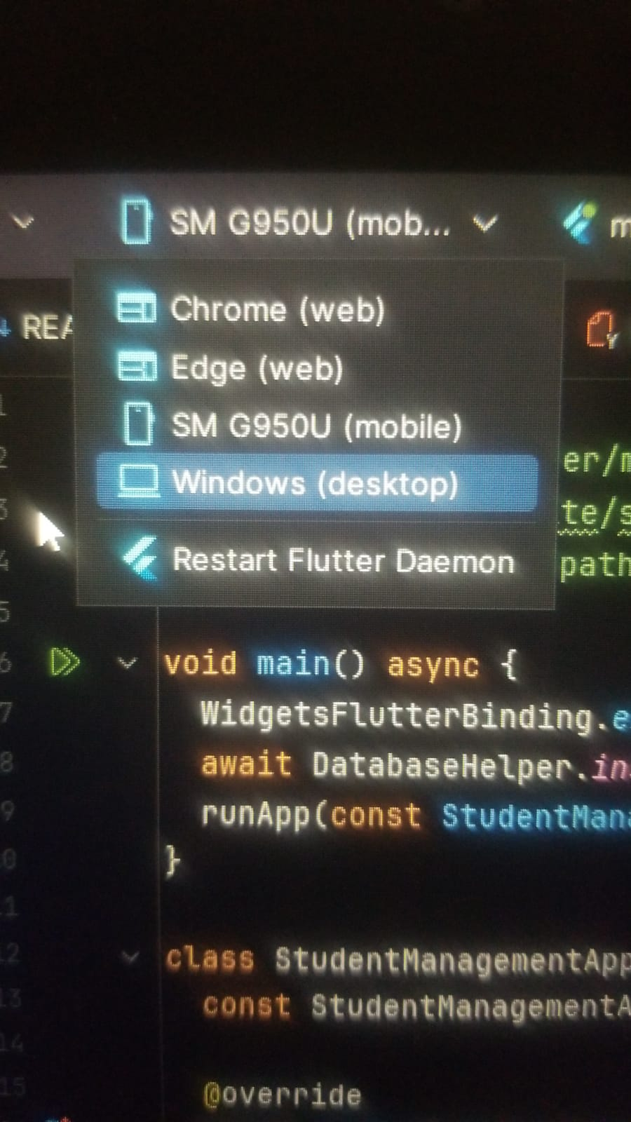

Challenge two:
Problem: kept being unable to download sdk for flutter
Trials: had to uninstall git and install it again because I thought it was the one causing issue. but unfortunately, it wasn’t the cause.
Solution: I had to install the flutter manually instead of using the visual studio.

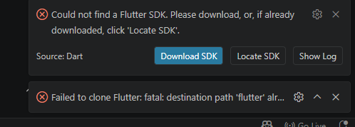

Challenge three:
Configuration File Spacing Error
- The Problem: When we added the database tools (sqflite and path) into pubspec.yaml, the app refused to compile. The system threw syntax alignment errors because YAML files are extremely strict about text margins.
- The Trial: We tried saving and building the project, but Android Studio flagged the lines with wavy red error marks, blocking the package download.
- The Solution: We manually fixed the indentation by giving exactly two spaces at the front of sqflite: and path:. This lined them up perfectly under cupertino_icons: and allowed the configuration code to parse smoothly.

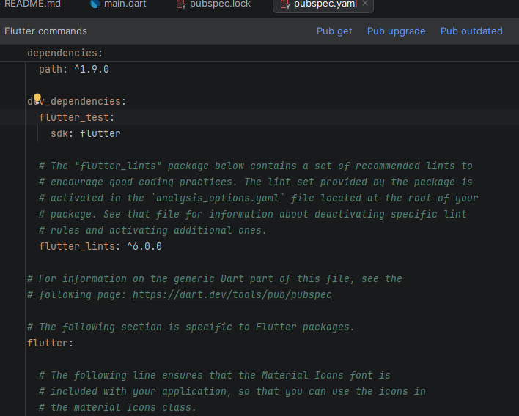

Personal Reflection
Setting up the mobile coding tools was a great start. Learning how files are organized in Android Studio helped me understand how mobile apps are built from scratch. Fixing the initial path setups gave me confidence in managing a real programming environment.

WEEK2:STUDENT MINI MANAGEMENT
Login page:
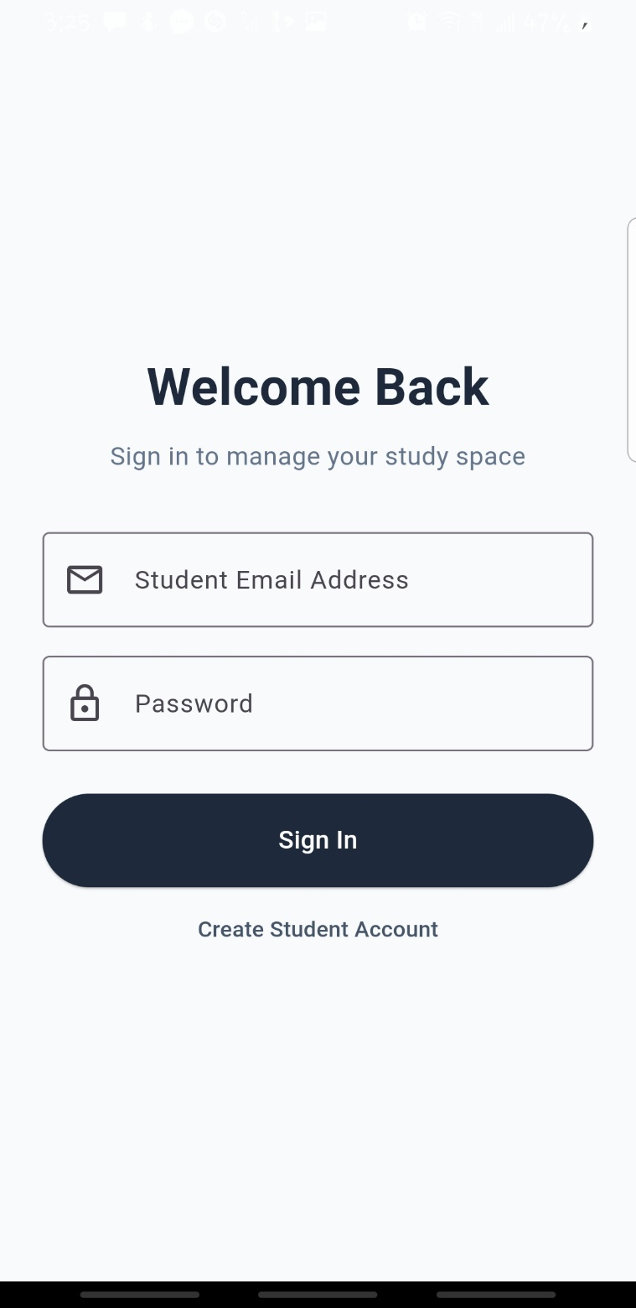
Student create account:
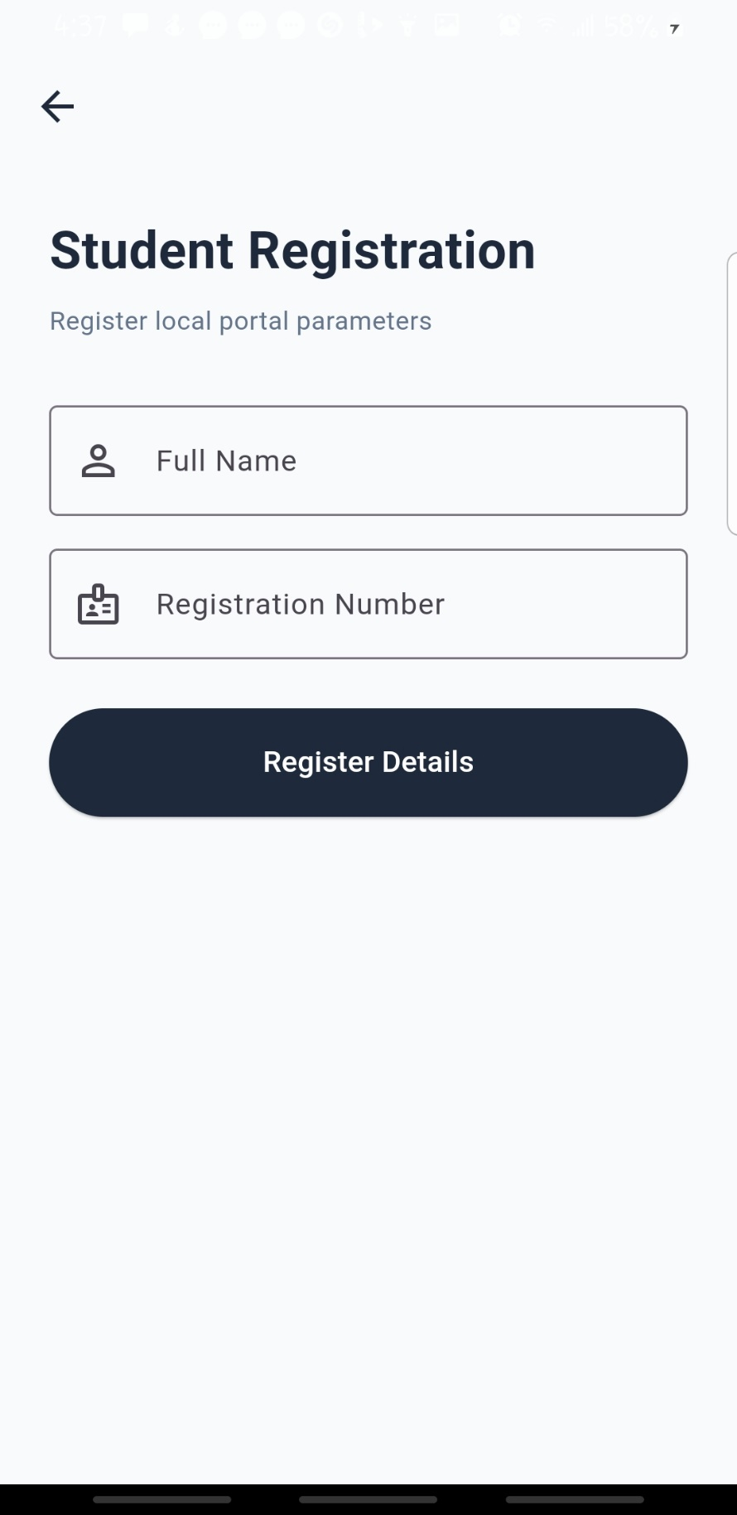
After signing in, Dashboard:
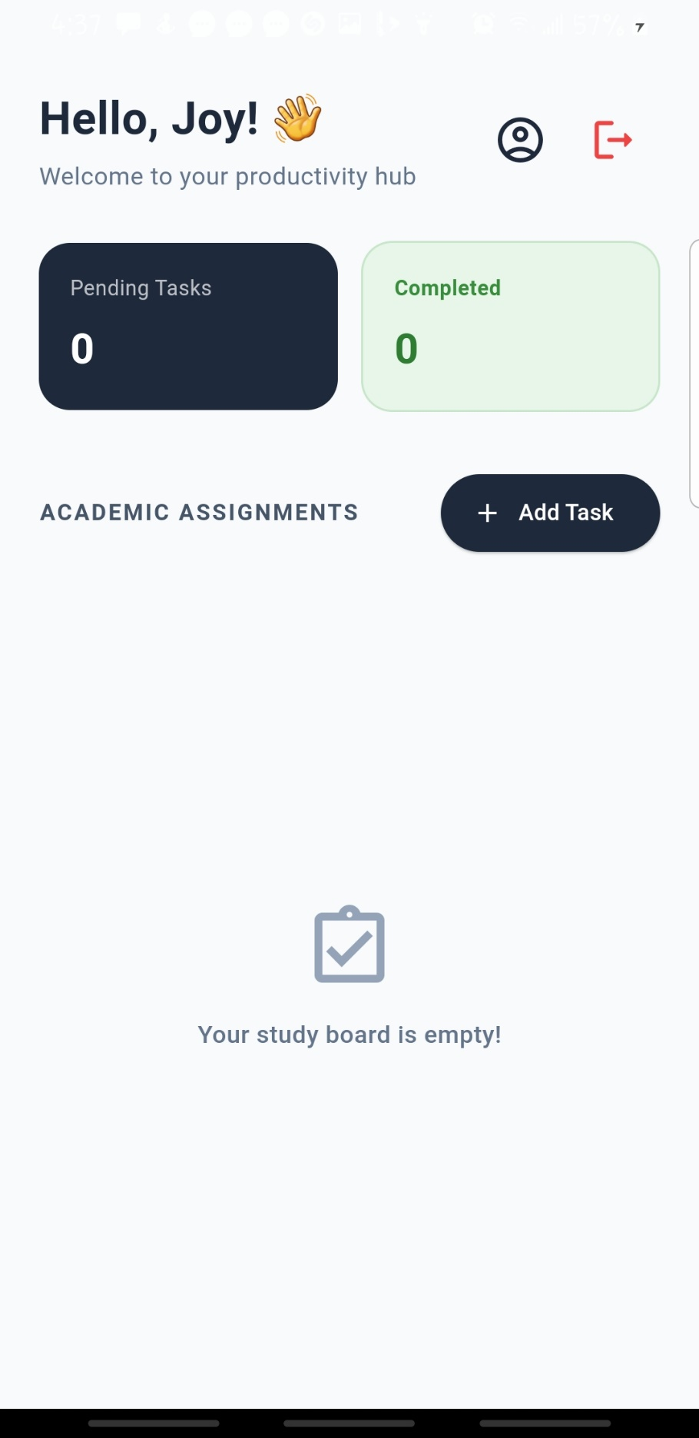
References:
• Android Studio & IntelliJ IDEA Tools:
Google. (2025). Android Studio Dolphin and beyond: The official integrated development environment for Android application development. Android Developers. https://developer.android.com/studio
• Flutter Framework & Cross-Platform Architecture:
Google. (2026). Flutter documentation: Building architectural layouts and managing state transitions. Flutter Dev. https://docs.flutter.dev/
• Dart Programming Language & Asynchronous Streams:
Framework, D. (2025). Dart language guide: Utilizing futures, async, and await operations for non-blocking I/O threads. Dart Dev. https://dart.dev/guides
• SQLite Embedded Database Engine & Local CRUD Storage:
Hipp, D. R. (2024). SQLite: An self-contained, serverless, zero-configuration, transactional SQL database engine. SQLite Org. https://www.sqlite.org/
• The sqflite Plugin for Flutter Integration:
Teixeira, A. (2025). Sqflite package: SQLite plugin for Flutter supporting core database transactions and automated schema migrations (Version 2.3.0). Pub. dev. https://pub.dev/packages/sqflite

